|  |  |
| --- | --- |
|  |  |
| EDF Scheduler |  |
|  |  |
|  | 23/9FWD RTOS |
|  | Abdulrahman Yasser |

### Analytical Calculations

* “Button_1_Monitor”: Task 1: {P = 50, E=13.3, D = 50}
* “Button_2_Monitor”: Task 2: {P = 50, E=13.3, D = 50}
* “Periodic_Transmitter”: Task 3: {P = 100, E=20.3, D = 100}
* “Uart_Receiver”: Task 4: {P = 20, E=15.5, D = 20}
* “Load_1_Simulation”: Task 5: {P = 10, E=5000, D = 10}
* “Load_2_Simulation”: Task 6: {P = 100, E=12000, D = 100}

## CPU load

* + 1. Hyperperiod = 100ms

$$\frac{(2*13.3) +(2*13.3)+(1*20.3)+(5*15.5)+(10*5000)+(1*12000)}{100000}=62.161\%$$

## Rate-monotonic utilization

$$U= \frac{13.3}{50000}+ \frac{13.3}{50000}+ \frac{20.3}{100000}+ \frac{15.5}{20000}+ \frac{5000}{10000}+ \frac{12000}{100000}=0.6239$$

$$Urm=6*\left(2^{\frac{1}{6}}-1\right)= 0.7347$$

The system is schedulable because 0.73 > 0.62

## Time demand analysis

* + 1. Time demand for task 1:

$$w\left(1\right)=13.3+0$$

$$w\left(50000\right)=13.3+0$$

$$13.3<50000$$

T1 is schedulable

* + 1. Time demand for task 2

$$w\left(1\right)=\frac{1}{50000}13.3+13.3$$

$$w\left(50000\right)=\frac{1}{50000}13.3+13.3$$

$$26.6<50000$$

T2 is schedulable

* + 1. Time demand for task 3:

$$w\left(1\right)=\frac{1}{50000}13.3+\frac{1}{50000}13.3+20.3$$

$$w\left(100000\right)=\frac{1}{50000}13.3+\frac{1}{50000}13.3+20.3$$

$$46.9<100000$$

T3 is schedulable

* + 1. Time demand for task 4:

$$w\left(1\right)=\frac{1}{50000}13.3+\frac{1}{50000}13.3+\frac{1}{100000}20.3+15.5$$

$$w\left(20000\right)=\frac{1}{50000}13.3+\frac{1}{50000}13.3+\frac{1}{100000}20.3+15.5$$

$$62.4<20000$$

T4 is schedulable

* + 1. Time demand for task 5:

$$w\left(1\right)=\frac{1}{50000}13.3+\frac{1}{50000}13.3+\frac{1}{100000}20.3+\frac{1}{20000}15.5+5000$$

$$w\left(10000\right)=\frac{1}{50000}13.3+\frac{1}{50000}13.3+\frac{1}{100000}20.3+\frac{1}{20000}15.5+5000$$

$$5062.4<10000$$

T5 is schedulable

* + 1. Time demand for task 6:

$$w\left(1\right)=\frac{1}{50000}13.3+\frac{1}{50000}13.3+\frac{1}{100000}20.3+\frac{1}{20000}15.5+\frac{1}{10000}5000+12000$$

$$w\left(100000\right)=\frac{1}{50000}13.3+\frac{1}{50000}13.3+\frac{1}{100000}20.3+\frac{1}{20000}15.5+\frac{1}{10000}5000+12000$$

$$17062.4<100000$$

T6 is schedulable

### Simso result

## Implementing our tasks

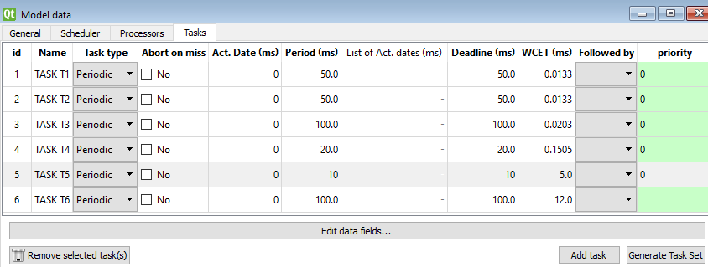

Figure 1Tasks implementation in simso

## Results

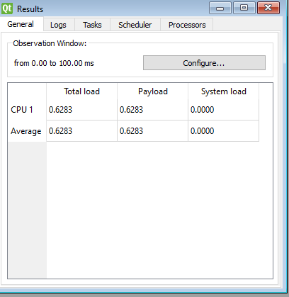

Figure 2 Simso Load result

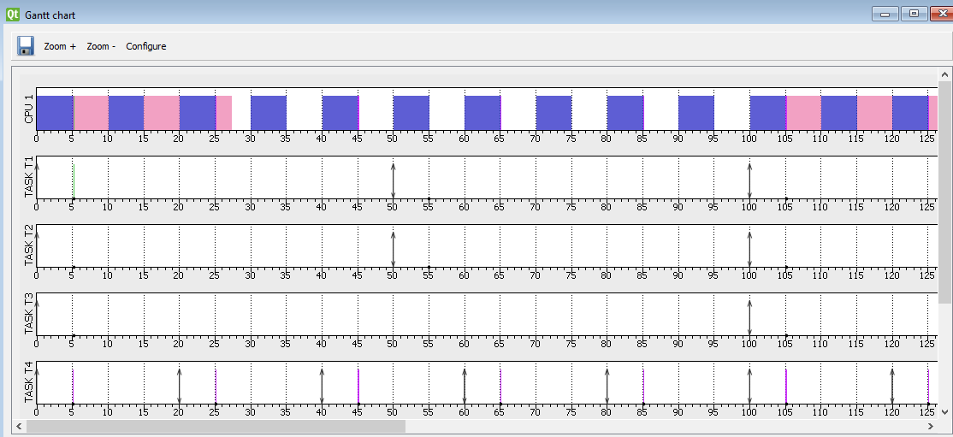

Figure 3 Simso execution in 300ms period

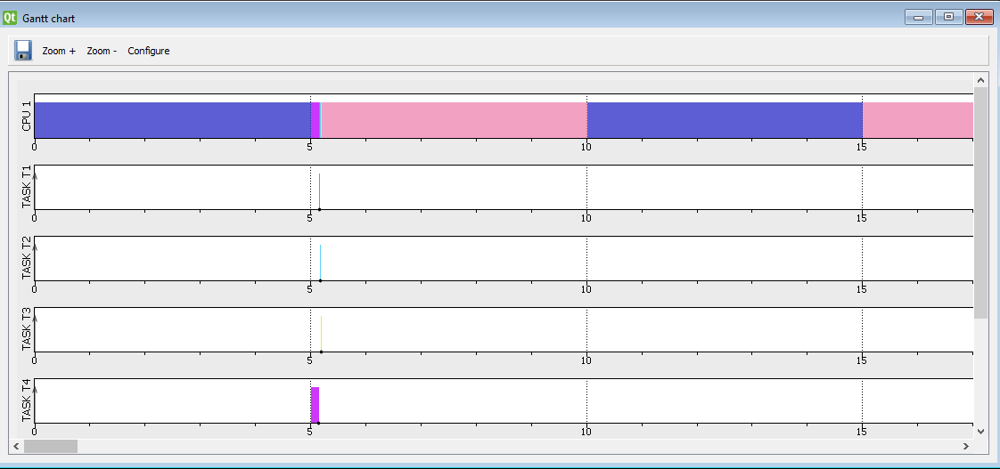

Figure 4 execution of small tasks in simso

### Using Keil Simulator in run time

## Tasks execution times

#### Task 1: Button_1_Monitor: 13.2 µs

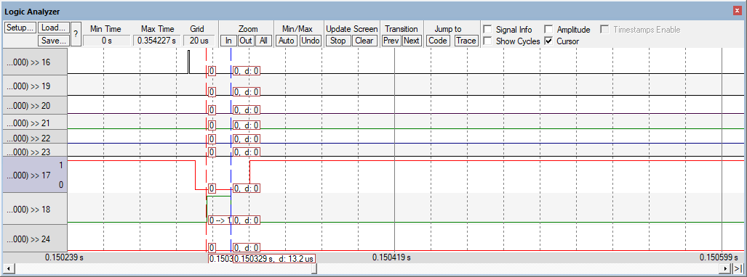

Figure 5 Button_1_Monitor execution time

#### Task 2: Button_2_Monitor: 13.3 µs

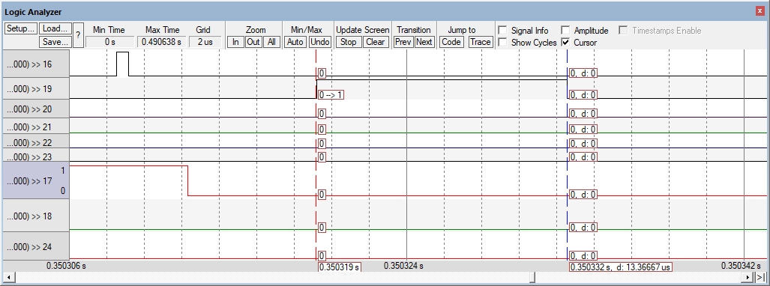

Figure 6 Button_2_Monitor execution time

#### Task 3: Periodic_Transmitter: 20.35 µs

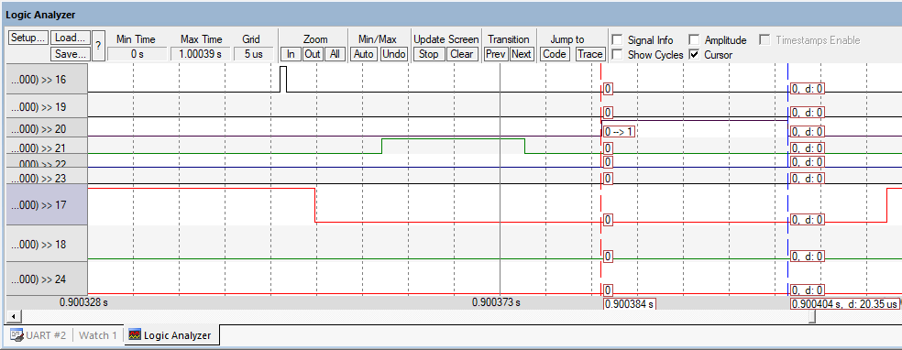

Figure 7 Periodic_Transmitter

#### Task 4: Uart_Receiver: 15.5µs or 26µs

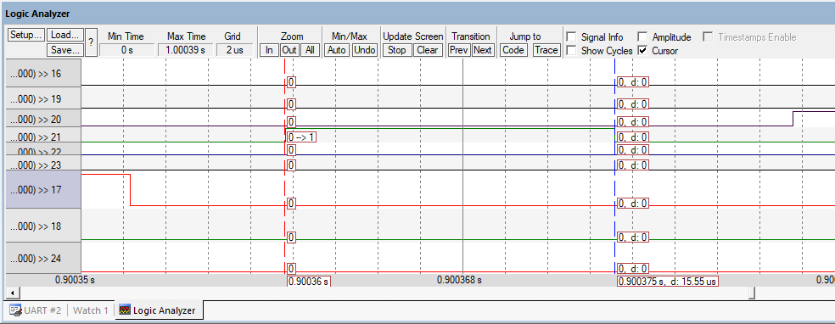

Figure 8 Uart_Receiver execution time when Queue is empty

When there is data to send

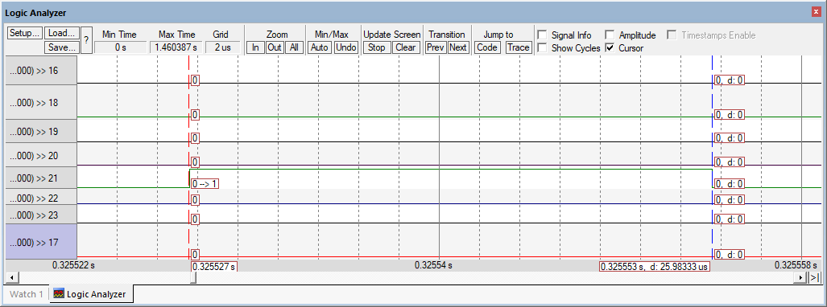

Figure 9 Uart_Receiver execution time when Queue is full

#### Task 5: Load_1_Simulation: 5.01ms

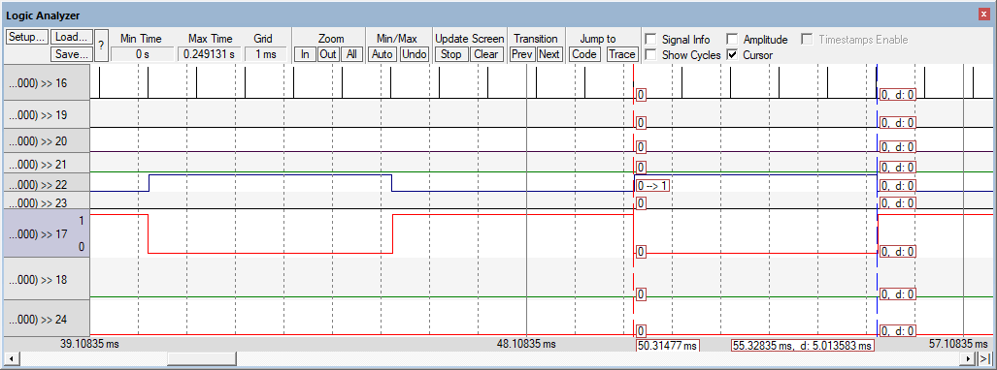

Figure 10 Load_1_Simulation execution time

#### Task 6: Load_2_Simulation: 12.013ms

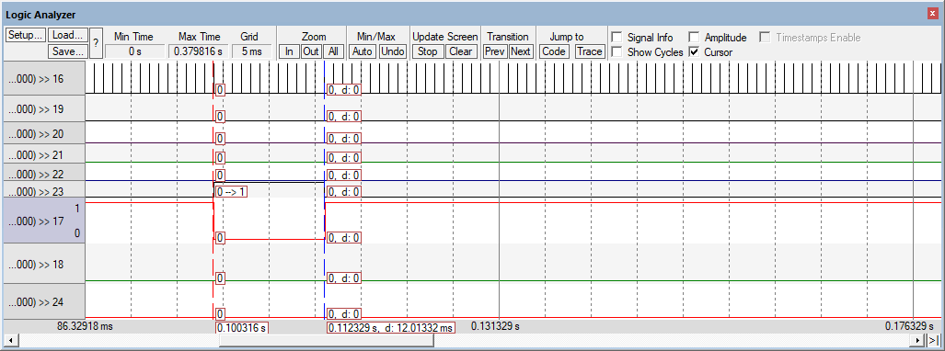

Figure 11 Load_2_Simulation execution time

## CPU usage

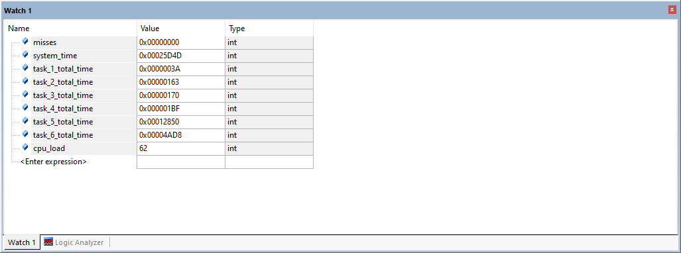

Figure 12 Tasks execution time and CPU load in run time

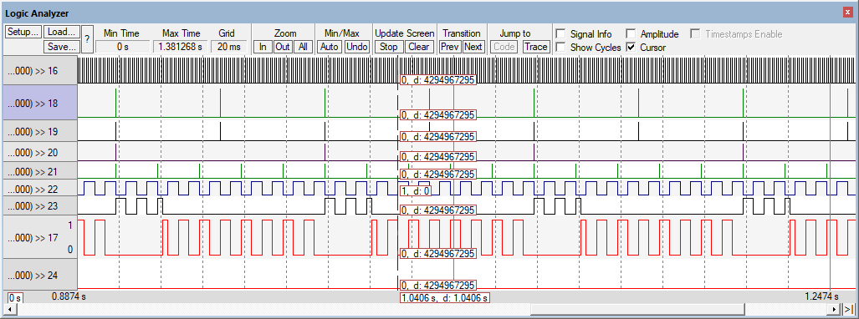

Figure 13 Live screen from the running program